

Informatics Practices

Project on

Bank Management

Made By - Omanshu Mahawar

XII – A

Submitted To -

Mr. Deepak Panicar Kumar

( HOD Informatics Practices )

Acknowledgement

I would like to express my special thanks of gratitude to my teacher, Mr. Deepak Panicar Kumar as well as our principal Mrs. Jayshree Pareek, who gave me this opportunity to do this project which helped me in doing a lot of research and I came to know about so many new things.

I am really thankful to them.

Secondly, I would also like to thank my parents and friends who helped me a lot in finalizing this within the limited time frame.

Certificate

This is to certify that this Project File has been made by Omanshu Mahawar of class XII – A under my guidance and has completed it successfully.

Mr. Deepak Panicar Kumar

( HOD Informatics Practices )

Front-End

Netbeans

**NetBeans** is an integrated development environment (IDE) for developing primarily with java, but also with other languages, in particular php, c/c++, and html. It is also an application platform frame work for java desktop application and others.

The netbeans ide is written in java an run on windows, os x, linux, solaris and other platforms supporting a compatible jvm

The netbeans platform allows application to be developed from a set of modular software components called modulus. application based on the netbeans platform can be extended by third party developers.

Introduction to Java

Java is both a programming language and a platform. It is designed to deliver and run highly interactive, dynamic and secure application on networked computer system.

Java compiler produces a special format called byte code

i.e a machine instruction for a java processor chip called java virtual machine. (Java interpreter)

The byte code if independent of the computer system it has to run upon.

Characteristics of Java are:-

1. The java programs need to be written just once i.e WORA :- Write Once Run Anywhere.
2. It is a light weight code.
3. It offers weight code.
4. It offers built-in graphics.
5. It is an Object-Oriented language.
6. It supports multimedia.
7. It is platform independent.
8. It is an open source product.
9. NetBeans IDE is free, opensource, cross-platform IDE (Integrated Development Environment) with built-in support for java programming language . It runs anywhere there’s a JVM

Database

(The Back-End)

The database helps you to save data permanently in secondary storage devices and keeps data ready for future reference, modification and addition. In the earlier lessons about database concepts, you have learnt about how to create a table, modify content of a table, add new content in the table, delete content from a table and retrieve content from a table in various forms.

MySQL

MySQL is a relation database management system (RDBMS) . It is pronounced as “My Sequel”. MySQL was originally founded and developed in Sweden by David Axmark, Allan Larsson and Michael Widenius, who had worked together since the 1980s.

MySQL Tables

Login:

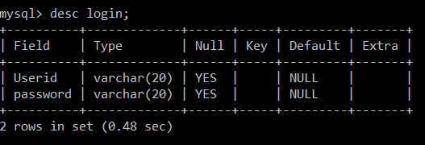

New account:

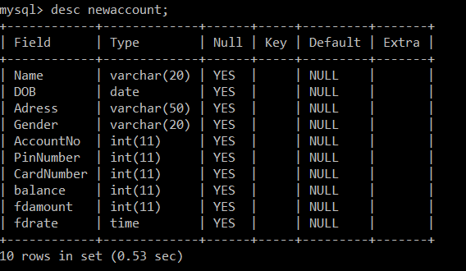

New Employee:

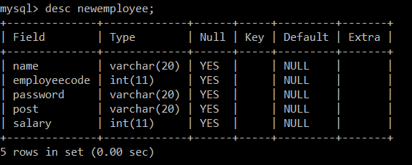

**Fixed deposit:**

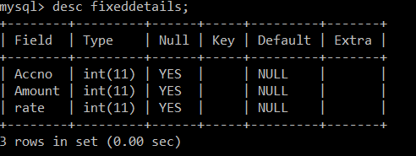

**Customer:**

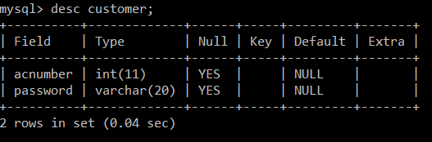

MySQL queries

**1. Create and open Database named MYORG**.





**2. Write a command to display the name of current month**.

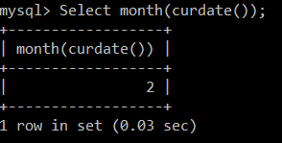

**3. Write a query to find out the result of 63**

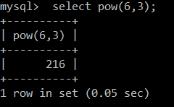

**4. Create a table name EMP with following structure**

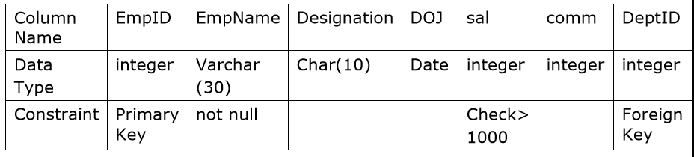

create table emp (EmpID integer primary key, EmpName varchar(30) not null, Designation char(10), DOJ date, Sal integer check(sal>1000), Comm integer, DeptID integer, Foreign key(DeptID) references DEPT(DeptID) );

**5. Insert the first record in table emp**

insert into emp Values(8369,’SMITH’,’CLERK’,’18-12-1990’,800,200,10);

**6. Write a query to display EmpName and Sal of employees whose salary are greater than or equal to 2200**

select empname, sal from emp where sal>=2200;

**7. Write a query to display details of employees who are not getting commission.**

select * from emp where comm is NULL;

**8 . Write a query to display employee name and salary of those employees who don’t have their salary in range of 2500 to 4000.**

select empname, sal From emp Where sal not between 2500 and 4000;

**9 . Write a query to display the name of employee whose name contains “A” as third alphabet in Ascending order of employee names.**

select empname From emp Where empname like “__A%” Order by empname;

**10. Display the sum of salary and commission of employees as “Total Incentive” who are getting commission**

select sal+comm As “Total Incentive” From emp where comm is not NULL;

**11. Show the average salary for all departments with more than 5 working people.**

select avg(sal) From emp Group by deptid Having count(*)>5;

**12.Display the distinct designation offered by the Organization.**

select distinct designation From emp;

**13. List the count of Employees grouped by DeptID.**

select count(*) From emp Group by DeptID;

**14. Display the names of employees who joined on or after 01/05/1991.**

Select empname From emp Where DOJ>=’01/05/1991’;

**15. Display the employee records in order by DOJ.**

select * From emp Order by DOJ;

**16. Display the maximum salary of employees in each Department.**

select max(sal) From emp Group by department;

**17. Update all the records as add ‘Mr.’ with EmpName.**

update emp Set EmpName=concat(‘Mr’,EmpName);

**18. Display the name of Employees who is working in SALES department.**

select empname From emp, dept Where deptName=”SALES” and emp.DeptID=dept.DeptID;

**19. Drop the emp table.**

drop table emp;

**20. Delete all the records who is working as “CLERK”**

delete from emp Where designation=”CLERK”;

**21. Show the minimum, maximum and average salary of Managers.**

select min(sal), max(sal), avg(sal) From emp Where designation=”Manager”;

**22. Increase the salary of managers by 15%.**

update emp Set sal= sal + 0.15*sal Where designation=”Manager”;

**23. To display the name of those employees whose location is Delhi.**

select empname From emp, dept Where location=”Delhi” and emp.DeptID=dept.DeptID;

Login :

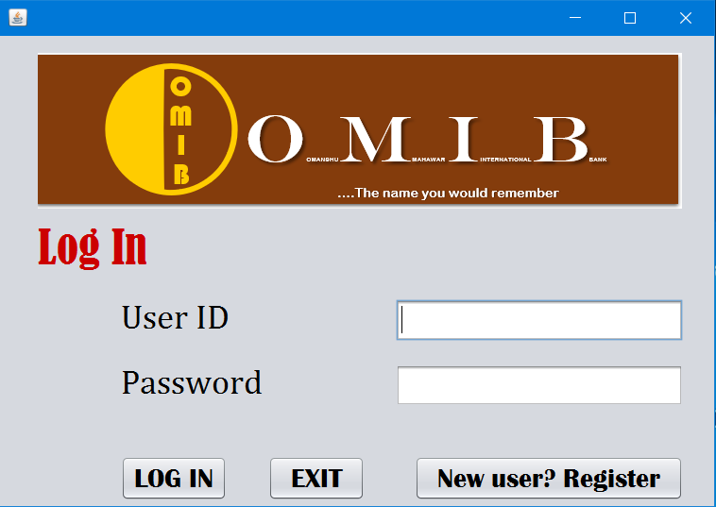

Import Statement :

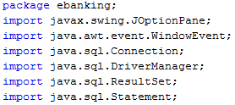

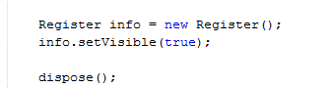Code for Register Button :

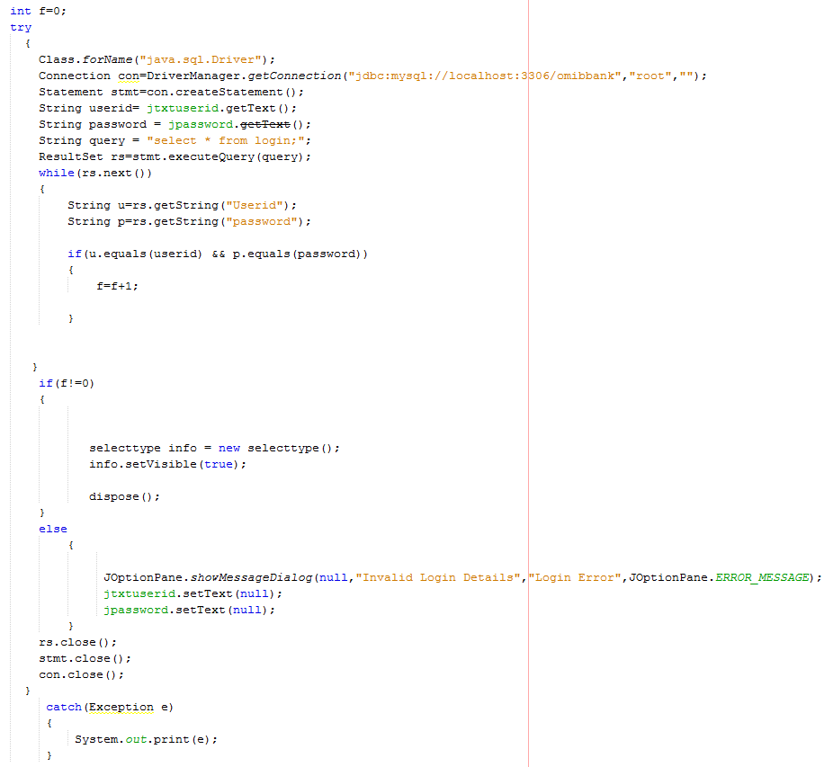Code for Login Button :

Register :

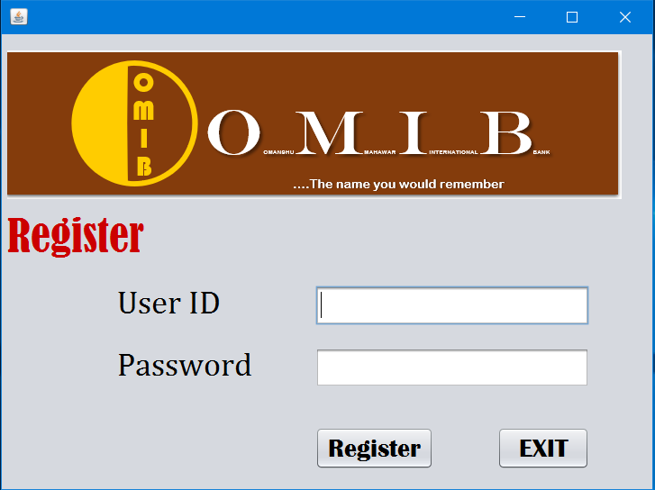

Import Statement :

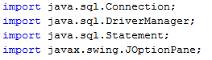

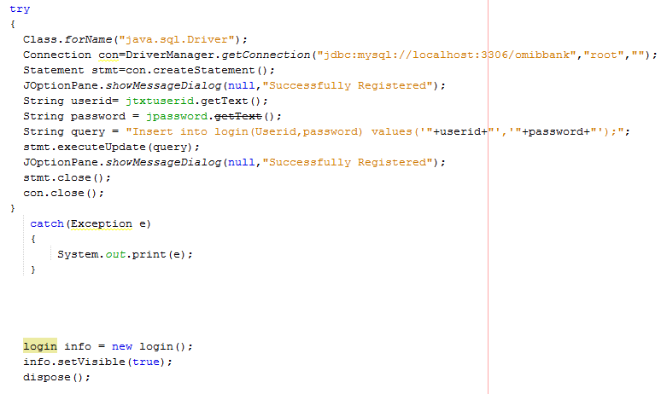Code for Register Button :

Code for Exit Button:



Login Type :

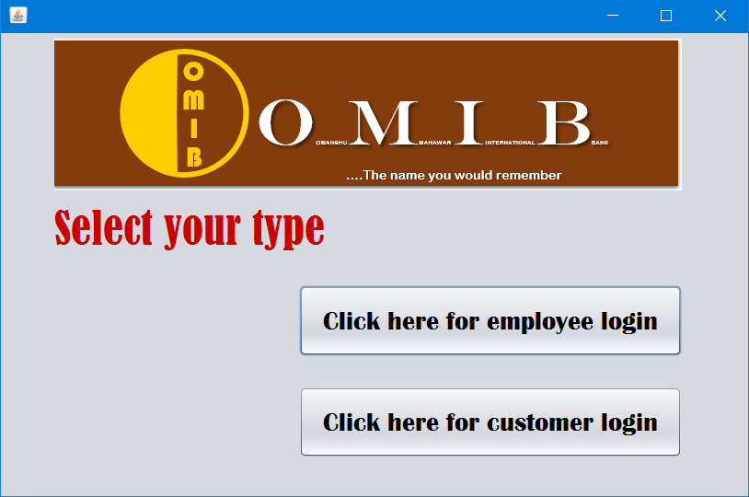

Code for Employee login button:

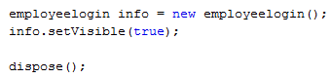

Code for Customer login button:



Employee Login :

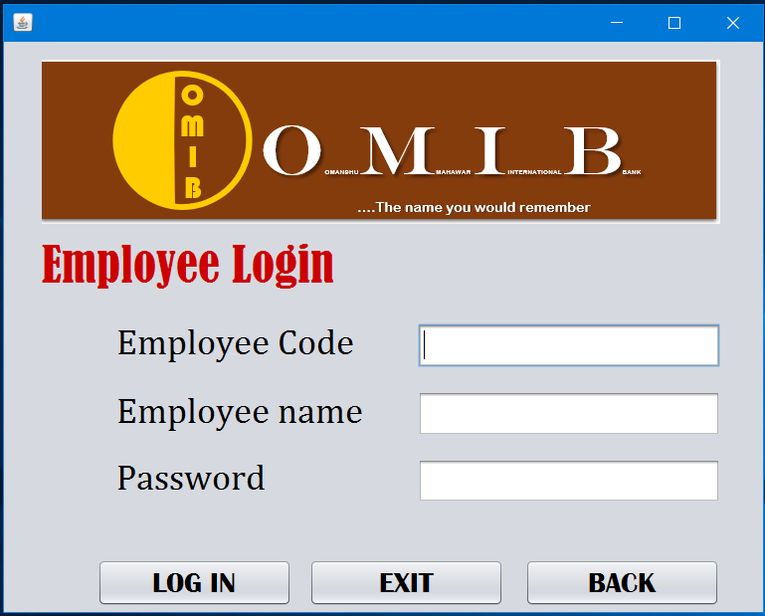

Import Statement :



Code for Log In button :

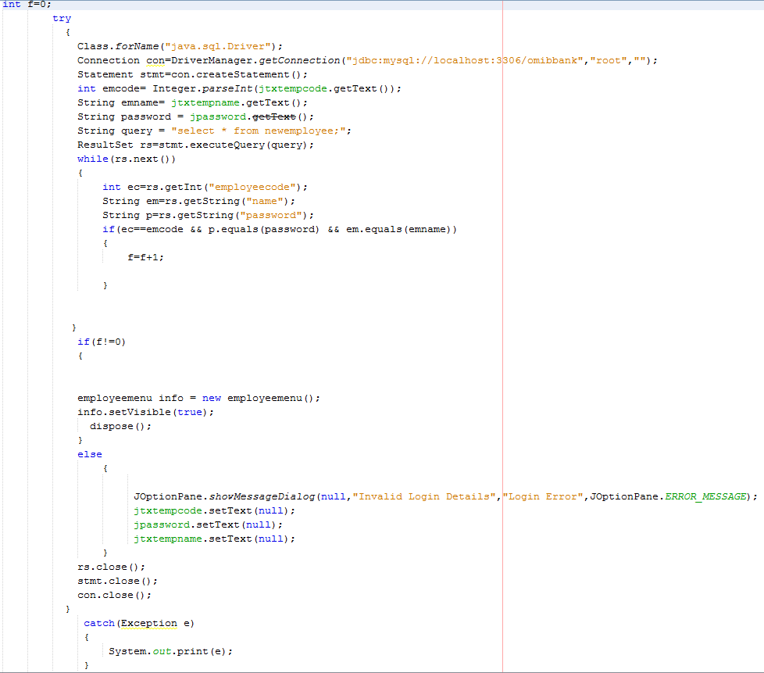

Code for Exit button :



Code for Back button :

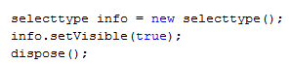

Customer Login :

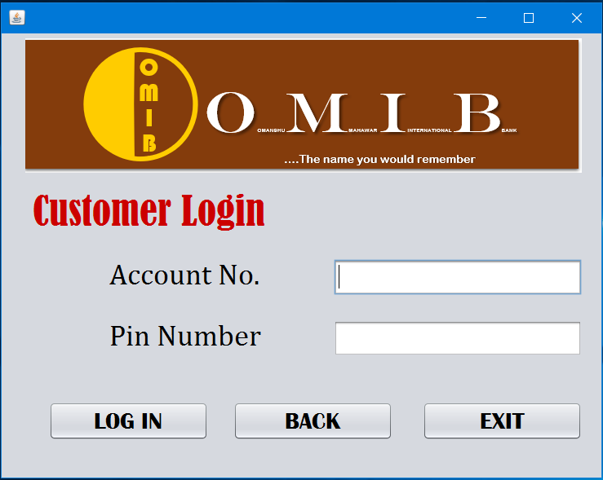

Import Statement :



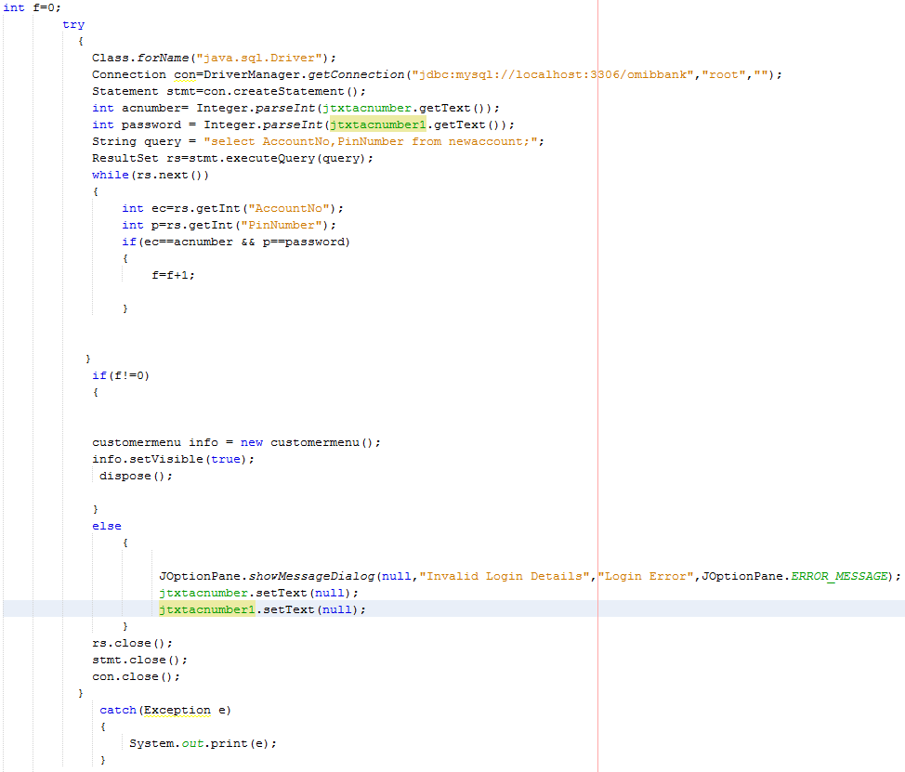Code for Log In button :

Code for Exit button :



Code for Back button :



Employee Menu :

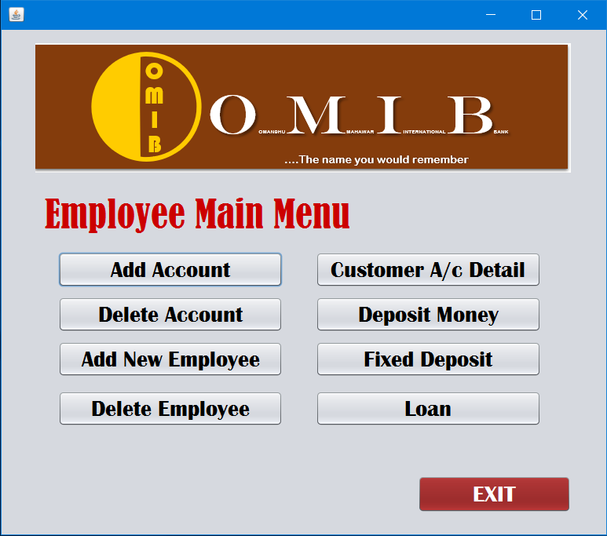

Code for Add New Account button:

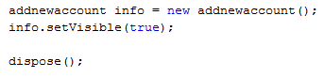

Code for Delete Account button:



Code for Add new Employee button:



Code for Delete Employee button:



Code for Account Detail button:



Code for Deposit Money button:



Code for Fixed Deposit button:



Code for Loan button:



Code for Exit button:



Add New Account :

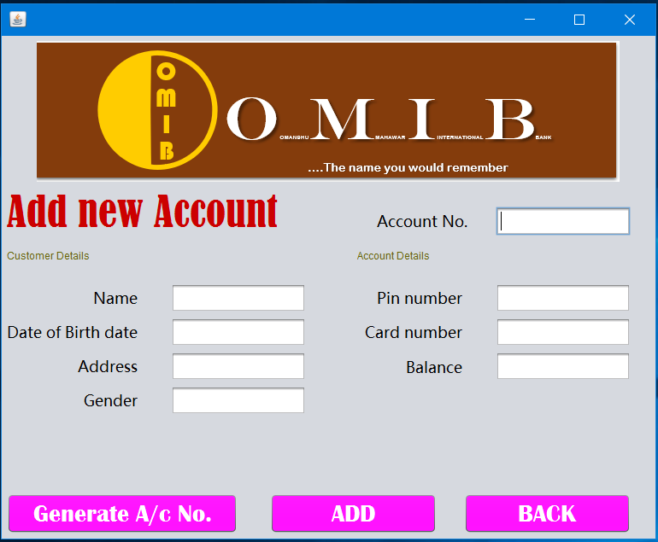

Import Statement :



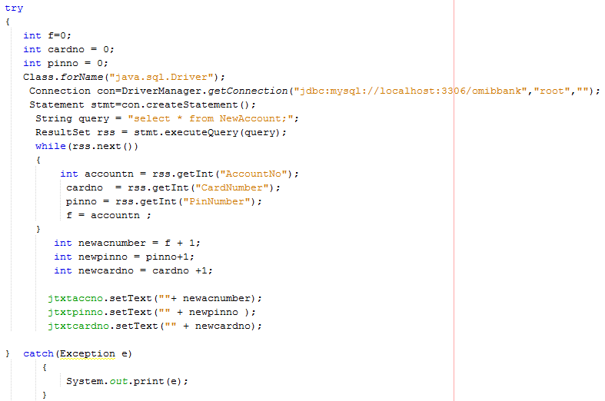Code for Generate A/c No. Button :

Code for Back Button :

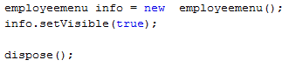

Code for Add Button :

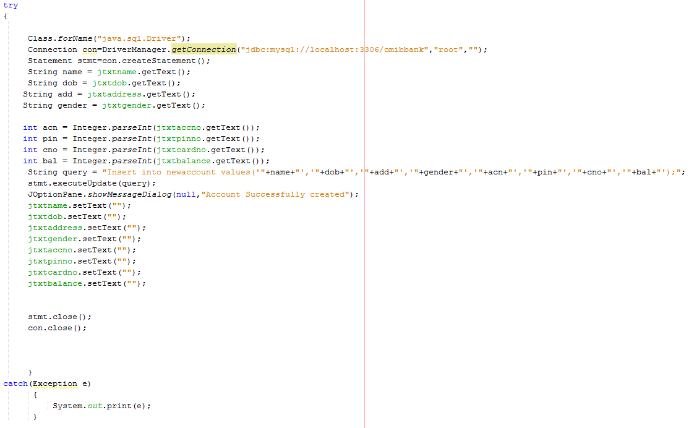

Delete Account :

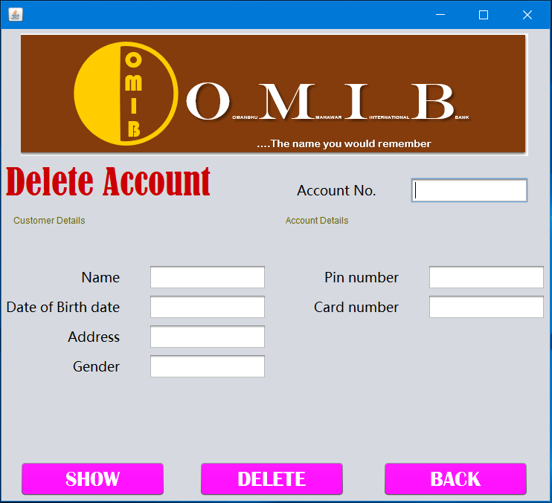

Import Statement :



Code for Show Button :

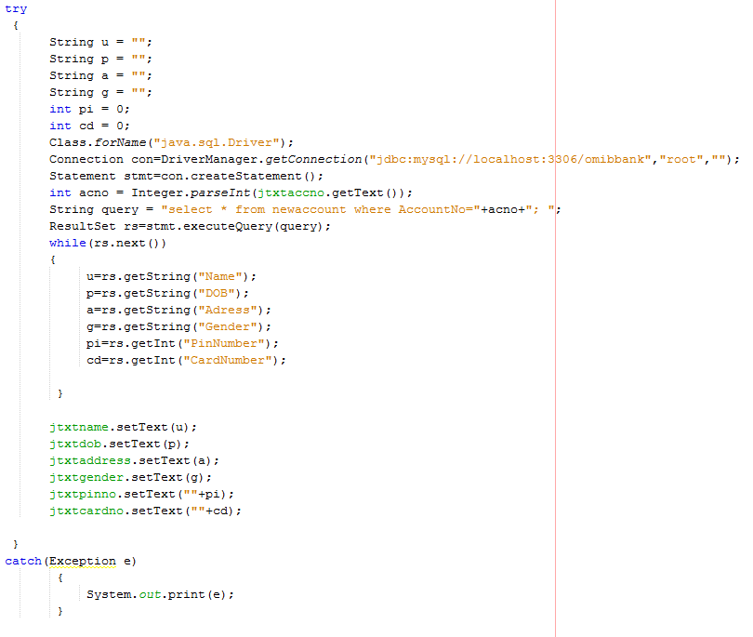

Code for Delete Button :

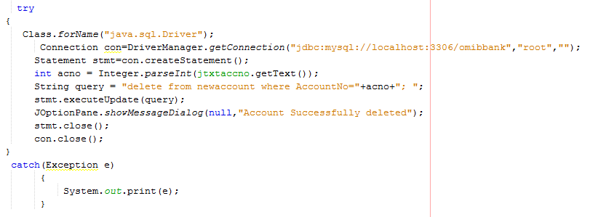

Code for Back Button :



Add New Employee :

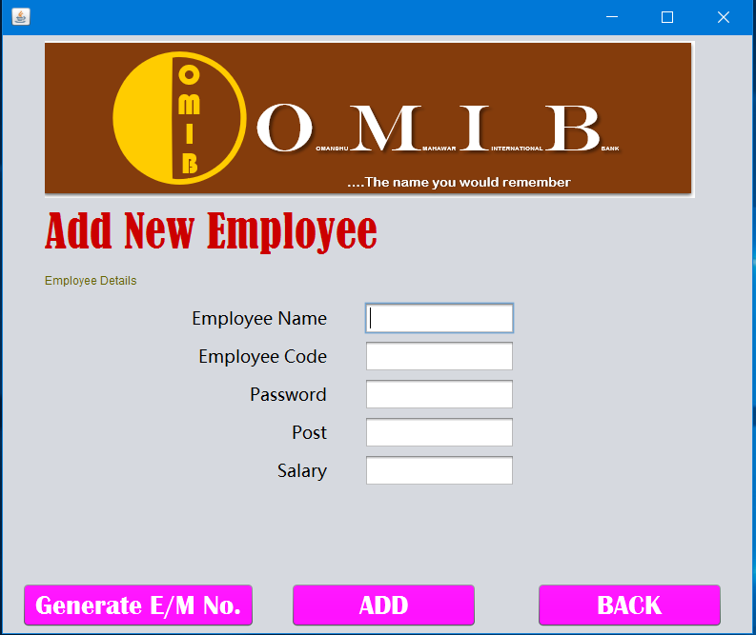

Import Statement :



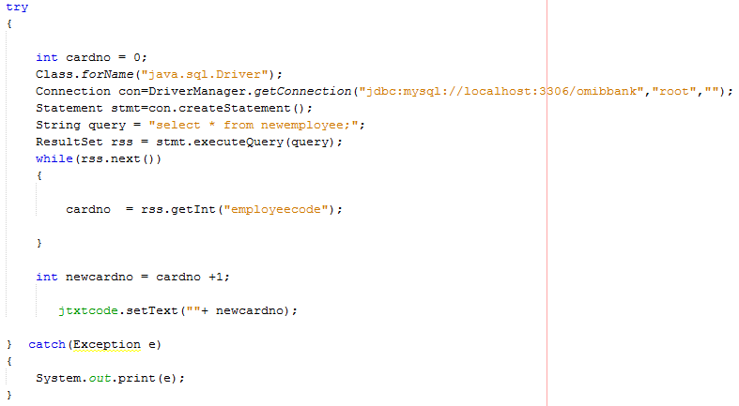Code for Generate E/m No. Button :

Code for Back Button :

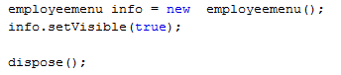

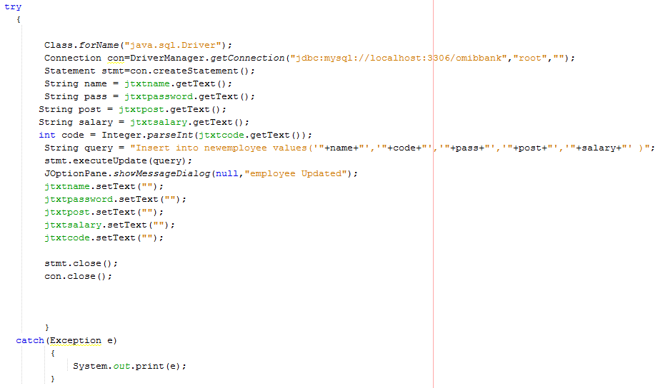Code for Add Button :

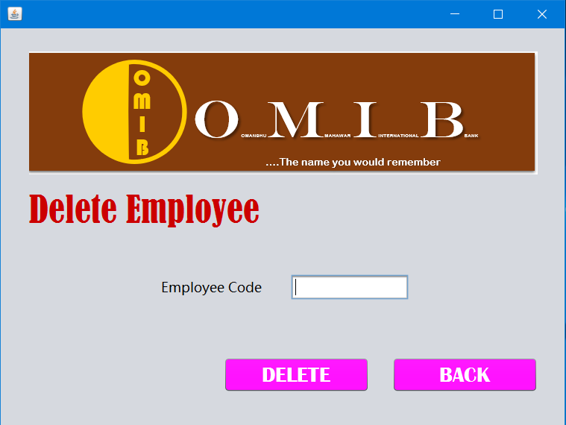Delete Employee :

Import Statement :



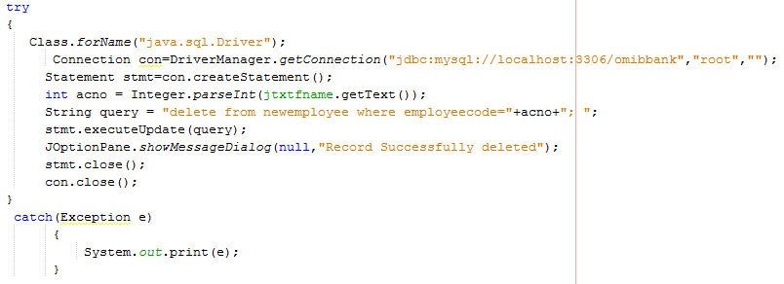Code for Delete Button :

Code for Back Button :



Account Details :

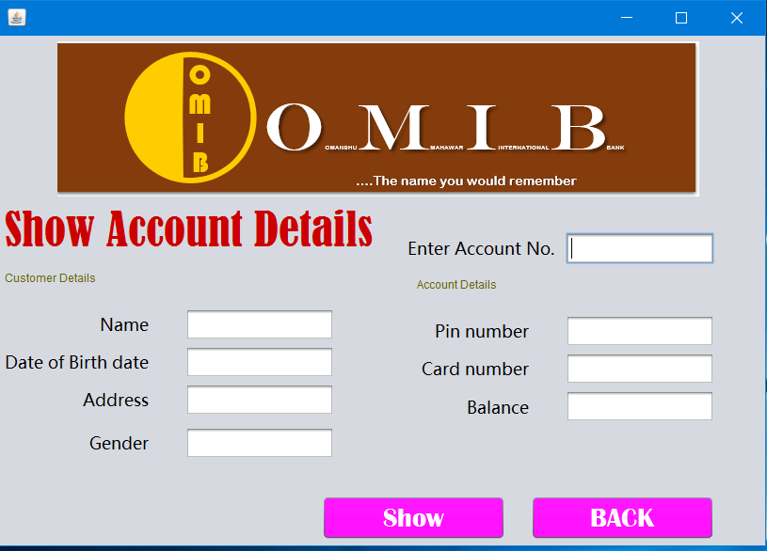

Import Statement :



Code for Show Button :

Code for Back Button :



Deposit Money :

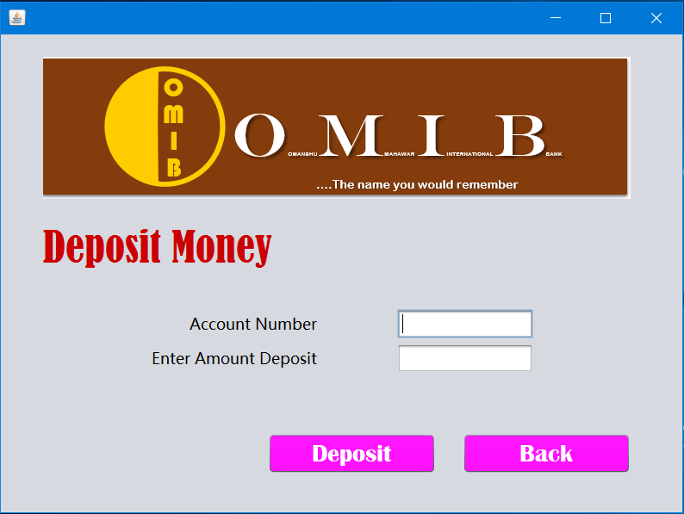

Import Statement :



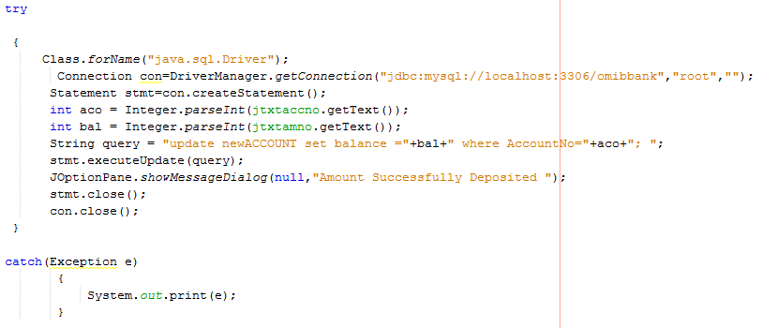Code for Deposit Button :

Code for Back Button :



Fixed Deposit :

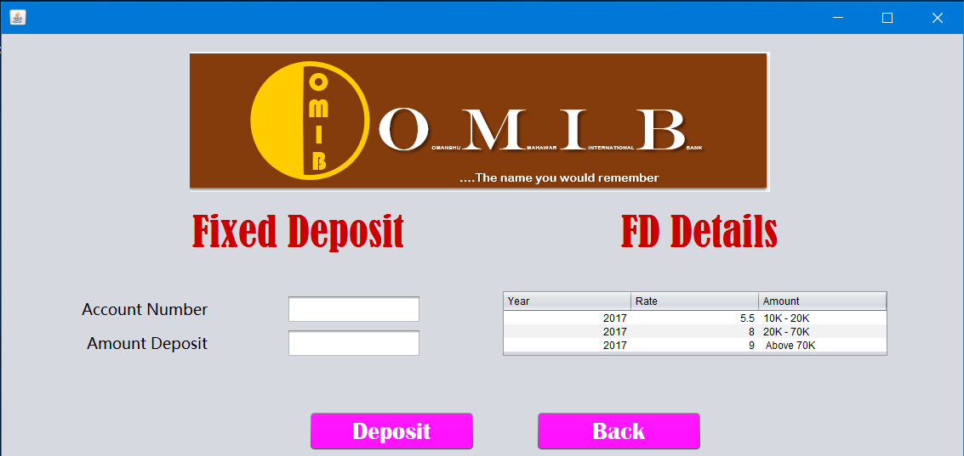

Import Statement :



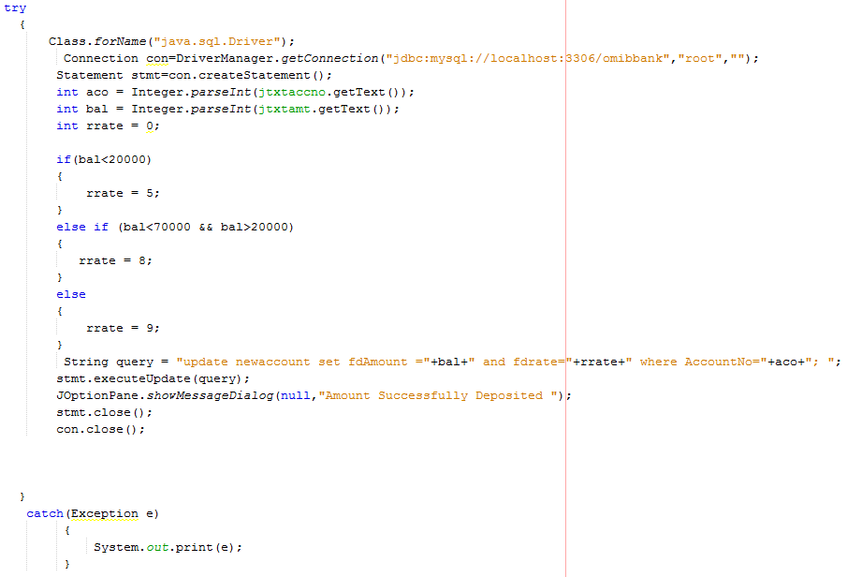Code for Deposit Button

Code for Back Button :



Loan :

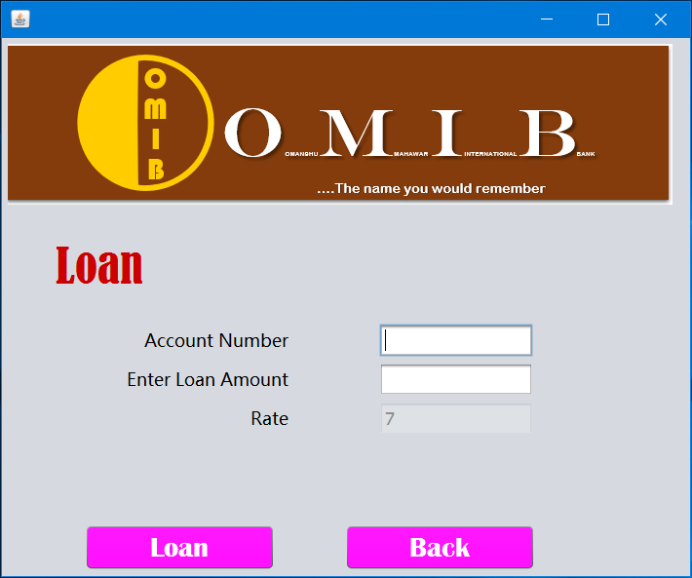

Import Statement :



Code for Loan Button :

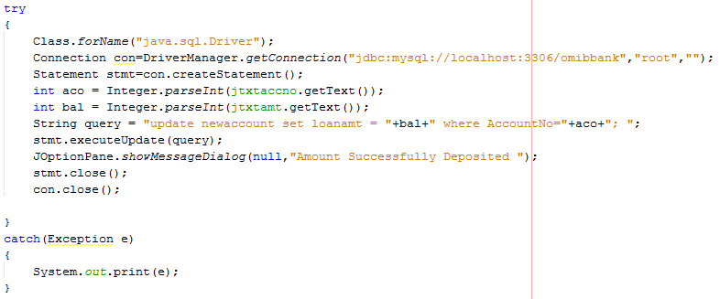

Code for Back Button :



Customer Main Menu :

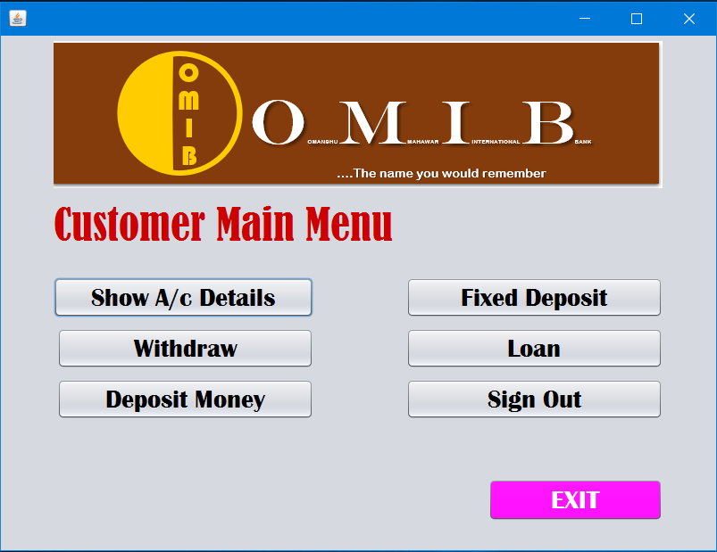

Code for Show A/c button:

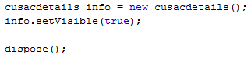

Code for Withdraw button:

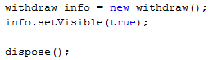

Code for Deposit Money button:

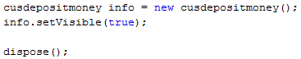

Code for Fixed Deposit button:



Code for Loan button:



Code for Sign Out button:



Code for Exit button:



Show A/c Details :

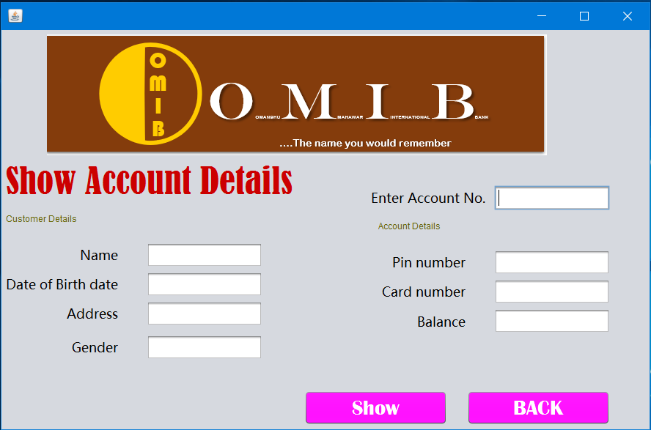

Import Statement :



Code for Show Button :

Code for back Button :



Show A/c Details :

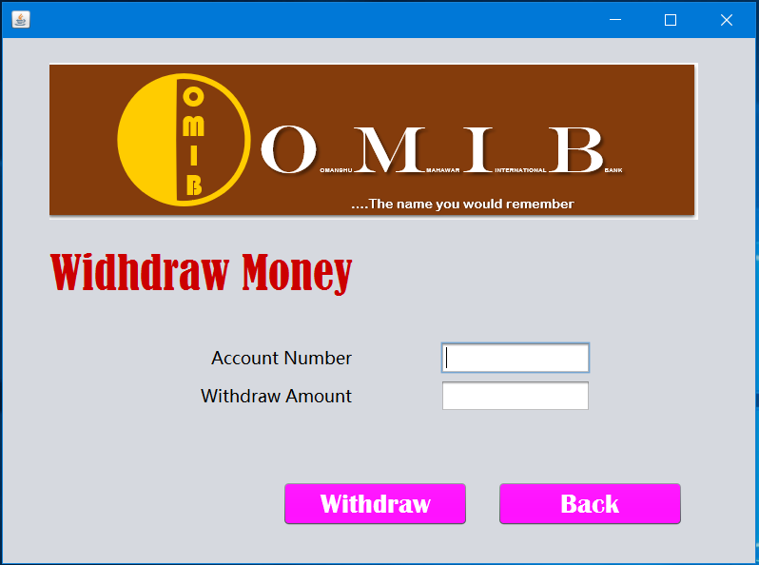

Import Statement :



Code for Withdraw Button :

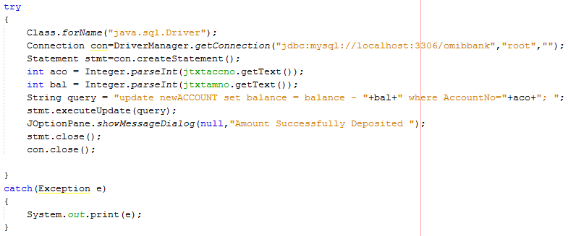

Code for back Button :



Deposit Money :



Import Statement :



Code for Deposit Button :

Code for Back Button :



Fixed Deposit :



Import Statement :



Code for Deposit Button

Code for Back Button :



Loan :



Import Statement :



Code for Loan Button :



Code for Back Button :

